Cau 1
- Use case diagram
- Use case track invoice
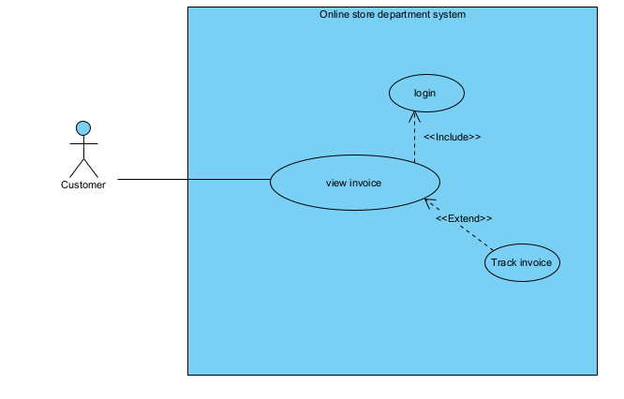
View invoice: customer view their list of invoice
Track in voice: customer see detail tracking of one of their iinvoice
Login: customer login into the system
- Approve order and export

View unexport order: staff

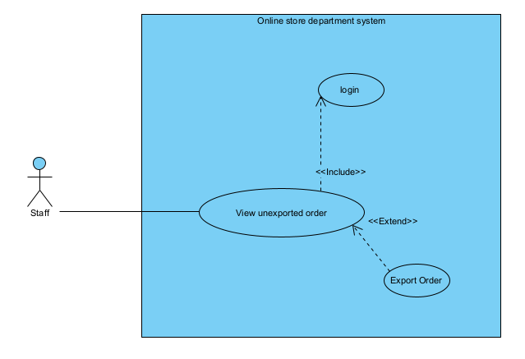
View unexported order: Staff view all the unexported order in the system
Export order: staff choose an unexported order, choose a delivery staff, update the order status, print the invoice and give the invoice and the goods to the delivery staff
Login: staff login into the system
- Scenario
- Use case track invoice
Use case | Track invoice
Actor | Customer
Pre con | Customer has account, and has invoice
Post con | Customer can see the detail tracking of an invoice
Main scenario | 1. The customer enter user name, password and click login  2. The system display the main customer interface  3. The customer click the track invoice button  4. The system display the track invoice menu, with a list of invoice  5. The customer click on an invoice  6. the system display the detail tracking of that invoice, include delivery staff, current location, expected date of deliver
Exception | 2. The system display login error
- Approve order and export
Use case | Approve order and export
Actor | Staff
Pre con | Staff has an account, system has at least 1 unapproved order
Post con | Order successfully approved and exported
Main scenario | 1. The staff enter user name, password and click login  2. The system display the main staff interface  3. The staff click the view order button  4. The system display the order list menu, with a list of order  5. The staff click on an order  6. the system display the the menu to enter delivery staff and approved button  7. the staff choose delivery staff and click approve  8. the system print the invoice
Exception | 2. The system display login error
Cau 2:
- Extract entity class name
- Track invoice
Customer -> a class
System -> too ambiguous
Interface
Button
Invoice -> a class

- Entity class diagram
